```

**Attrition Regression model is**

Atttrition = 0.7444+

(-0.00494)*(Age)+

(0.003806)*(distanceFroHome)+

(-0.003503)*(EnvironmentSatisfaction)+

(-0.06747)*(JobInvolemtn)+

(-0.03369)*(JobStatisfaction)+

(-0.00000899)*(MonthlyIncome)+

(0.01496)*(NumCompaniesWorked)+

(-0.05806)*(StockOptionLevel)

**Correlation of Attrition against all variables**

**Attrition has positive correlation with 4 variables**

DistanceFromHome 0.077923583

MonthlyRate 0.015170213

NumCompaniesWorked 0.043493739

PerformanceRating 0.002888752

[,1]

Age -0.159205007

Attrition 1.000000000

DailyRate -0.056651992

DistanceFromHome 0.077923583

Education -0.031372820

EmployeeNumber -0.010577243

EnvironmentSatisfaction -0.103368978

Gender -0.029453253

HourlyRate -0.006845550

JobInvolvement -0.130015957

JobLevel -0.169104751

JobSatisfaction -0.103481126

MonthlyIncome -0.159839582

MonthlyRate 0.015170213

NumCompaniesWorked 0.043493739

PercentSalaryHike -0.013478202

PerformanceRating 0.002888752

RelationshipSatisfaction -0.045872279

StockOptionLevel -0.137144919

TotalWorkingYears -0.171063246

TrainingTimesLastYear -0.059477799

WorkLifeBalance -0.063939047

YearsAtCompany -0.134392214

YearsInCurrentRole -0.160545004

YearsSinceLastPromotion -0.033018775

YearsWithCurrManager -0.156199316

**Not sure PCA part is correct**

**PCA Plot**

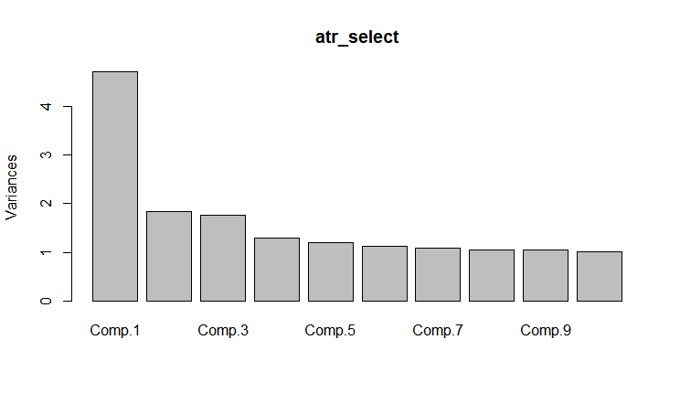

PCA Scree Plot

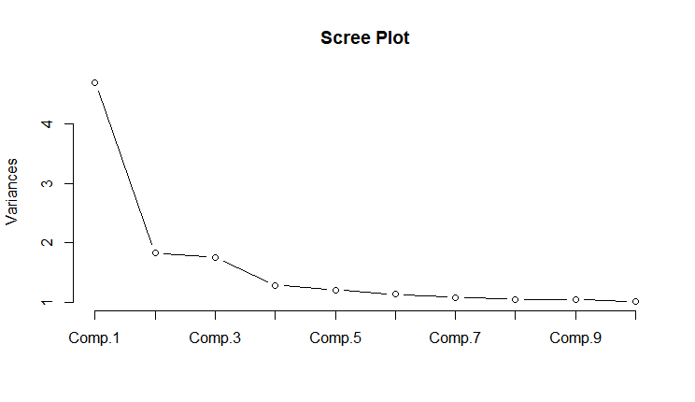



summary(atr_select)

Importance of components:

Comp.1 Comp.2 Comp.3 Comp.4 Comp.5 Comp.6

Standard deviation 2.1688786 1.35516176 1.32526423 1.13459652 1.0994319 1.06570881

Proportion of Variance 0.1809244 0.07063321 0.06755097 0.04951189 0.0464904 0.04368213

Cumulative Proportion 0.1809244 0.25155760 0.31910858 0.36862047 0.4151109 0.45879300

Comp.7 Comp.8 Comp.9 Comp.10 Comp.11 Comp.12

Standard deviation 1.03992804 1.02631185 1.02376109 1.00600194 1.00016282 0.98414172

Proportion of Variance 0.04159424 0.04051215 0.04031103 0.03892461 0.03847406 0.03725134

Cumulative Proportion 0.50038724 0.54089940 0.58121043 0.62013504 0.65860910 0.69586045

Comp.13 Comp.14 Comp.15 Comp.16 Comp.17 Comp.18

Standard deviation 0.97580308 0.95564733 0.94680128 0.94094131 0.92900871 0.88329162

Proportion of Variance 0.03662276 0.03512545 0.03447818 0.03405271 0.03319451 0.03000785

Cumulative Proportion 0.73248320 0.76760866 0.80208684 0.83613955 0.86933406 0.89934191

Comp.19 Comp.20 Comp.21 Comp.22 Comp.23 Comp.24

Standard deviation 0.82485391 0.72754784 0.71364390 0.52891178 0.474893844 0.450701200

Proportion of Variance 0.02616861 0.02035869 0.01958799 0.01075953 0.008674006 0.007812753

Cumulative Proportion 0.92551052 0.94586921 0.96545719 0.97621672 0.984890726 0.992703479

Comp.25 Comp.26

Standard deviation 0.375952608 0.219929971

Proportion of Variance 0.005436168 0.001860354

Cumulative Proportion 0.998139646 1.000000000